COLLABORATIVE INITIATIVE FOR FRENCH LANGUAGE COLLECTIONS  CIFNAL | 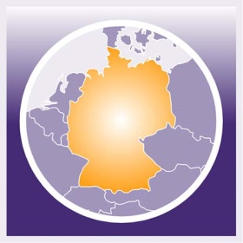  GERMAN-NORTH AMERICAN RESOURCES PARTNERSHIP  GNARP

Travel Stipend for

“New Directions for Libraries, Scholars, and Partnerships: an International Symposium” October 13, 2017

Application

Last name: First name:

Title: Place of employment:

Email address: Phone:

Address:

My institution is a member of ___ CIFNAL ___ GNARP

I am a Personal member of ___ CIFNAL ____ GNARP

I have been a professional librarian for _______ years.

Describe recent involvement in CIFNAL, GNARP, WESS or European scholarship/librarianship.

Describe any recent contribution to European scholarship/librarianship.

If you have submitted a proposal to present a paper or a poster session at the Frankfurt Symposium, briefly describe it.

What additional sources of funding would you use to supplement the travel stipend to attend the conference?

Statement (describe in 200 words or less how CIFNAL and/or GNARP would benefit from your participation at the Frankfurt Symposium)

Please return this form and other documentation as an attachment to jalspach@crl.edu no later than April 15, 2017. All applicants will notified by May 15, 2017.

Stipend awardees will be required to submit proof of registration and travel receipts in order to receive the stipend payment.
Stipend awardees will be required to submit a written report of approximately one page documenting their experience at the conference and outlining the ways in which their attendance at the conference contributes to the work of CIFNAL and/or GNARP.
Please address questions to jalspach@crl.edu

