COLLABORATIVE INITIATIVE FOR FRENCH LANGUAGE COLLECTIONS  CIFNAL | 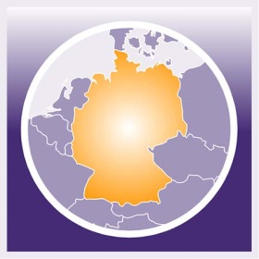  GERMAN-NORTH AMERICAN RESOURCES PARTNERSHIP  GNARP

Travel Stipend for

“New Shape of Sharing: Networks, Expertise, Information” May 2020

Application

Last name: First name:

Title: Place of employment:

Email address: Phone:

Address:

My institution is a member of ___ CIFNAL ___ GNARP ___ CRL

I am a personal member of ___ CIFNAL ____ GNARP

I have been a professional librarian/information professional for _______ years.

Describe recent contribution or involvement in CIFNAL, GNARP, ESS or European scholarship/librarianship.

If you have submitted a proposal to present a paper or a poster session at the New Shape of Sharing Forum, briefly describe it.

What additional sources of funding would you use to supplement the travel stipend to attend the forum?

Statement (describe in 200 words or less how CIFNAL and/or GNARP would benefit from your participation/attendance at the New Shape of Sharing Forum)

Please return this form and other documentation as an attachment to jalspach@crl.edu no later than December 10, 2019.
Stipend payments will be made after the forum is held.
In order to receive the stipend payment, stipend awardees will be required to submit travel receipts and a one-page report documenting their experiences at the forum, and how their attendance at the event contributes to the work of CIFNAL and/or GNARP. These reports will be shared with the CIFNAL and GNARP membership in order to allow others to learn about the conference sessions.
Stipend awardees from the United States will also need to complete a W-9 form.
Please address questions to Judy Alspach at jalspach@crl.edu

