COLLABORATIVE INITIATIVE FOR FRENCH LANGUAGE COLLECTIONS  CIFNAL | 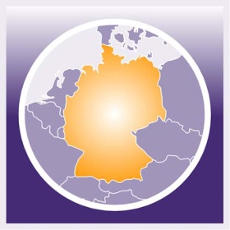  GERMAN-NORTH AMERICAN RESOURCES PARTNERSHIP  GNARP

Travel Stipend for

“New Directions for Libraries, Scholars, and Partnerships: an International Symposium” October 13, 2017

Application

Last name: First name:

Title: Place of employment:

Email address: Phone:

Address:

My institution is a member of ___ CIFNAL ___ GNARP ___ CRL

I am a Personal member of ___ CIFNAL ____ GNARP

I have been a professional librarian for _______ years.

Describe any recent interests, activities, or contributions related to European studies, or to relevant library services or scholarship/librarianship.

What additional sources of funding would you use to supplement the travel stipend to attend the symposium?

Statement (describe in 200 words or less how your attendance at the Frankfurt Symposium and Frankfurt Book Fair will contribute to your work as an academic librarian supporting research and learning services.)

Please return this form and other documentation as an attachment to jalspach@crl.edu.
Stipend awardees will be required to submit proof of registration and travel receipts in order to receive the stipend payment. Awardees will also be required to submit a one page report by December 1, 2017, documenting their experience at the symposium and outlining the ways in which their attendance contributes to their professional work.
Please address questions to jalspach@crl.edu

